## ­­葵花宝典

## 图形用户界面, 文本, 应用程序 描述已自动生成HW1

Question 1:

CPI: 0.2 x 1 + 0.4 x 2 + 0.1 x 3 + 0.3 x 4 = 2.5

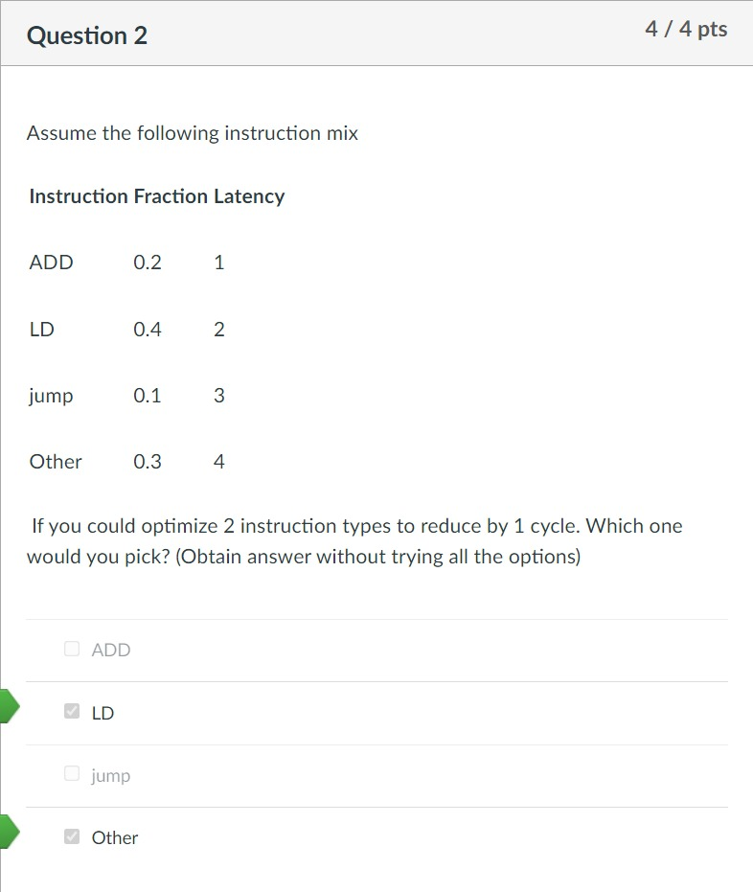IPC: 1 / 2.5 = 0.4

Question 2:

The fractions of LD and Other are the largest part, so we pick these two.

Question 3:

CPI = 0.2 x 1 + 0.4 x 2 + 0.1 x 3 + 0.3 x 4 = 2.5 IPC = 1 / 2.5 = 0.4

CPI = 0.2 x 1 + 0.4 x 2 + 0.1 x 3 = 1.3 IPC = 1 / 1.3 = 0.76

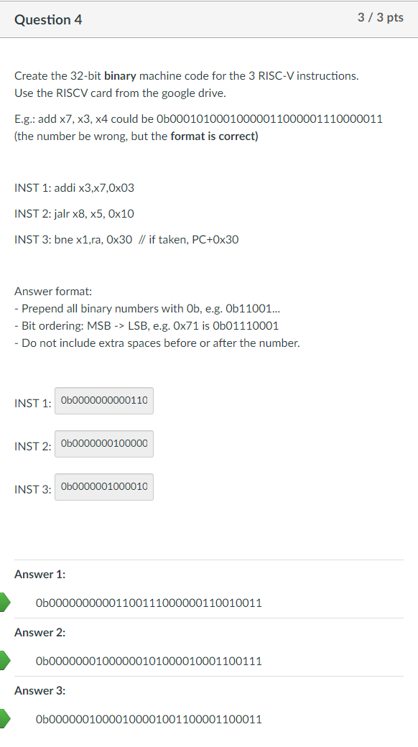So it’s impossible to get 1.5 on CPI.

Question 4:

(1): addi x3,x7,0x03 - im: 000000000011 rs1: 00111 func3: 000 rd: 00011 opcode: 0010011

(2): jalr x8, x5, 0x10 (!!: It's hex) - 000000010000 im: 000000010000 rs1: 00101 func3: 000 rd: 01000 opcode: 1100111

(3): bne x1,ra, 0x30 - im 12|10:5: 0000001 rs2: 00001 rs1: 00001 func3: 001 im 4:1|11: 10000 opcode: 1100011 00110000

Question 5:

(1): INST 1: addi x3,x7,0x03:

A: 0x07 ; Reason: The input is the content of the first register.

B: 0x27 ; Reason: This is what is built into the register.

C: 0X2A ; Reason: 0x27 + 0x03 = 0x2A.

D: 0x00 ; Reason: Not branch, not jump, so the output is 0.

(2): INST 2: jalr x8, x5, 0x10

A: 0x05 ; Reason: The input is the content of the first register.

B: 0x25 ; Reason: This is what is built into the register.

C: 0x35 ; Reason: 0x25 + 0x10 = 0x35.

D: 0x01 ; Readon: It's jump, so one of the input of OR gate is 1. Therefore, the output is 1.

(3): INST 3: bne x1,ra, 0x30  // if taken, PC+0x30

A: 0x01 ; Reason: The input is the content of the first register.

B: 0x21 ; Reason: This is what is built into the register.

C: 0x00 ; Reason: x1 = ra, so equal.

D: 0x00 ; Reason: Jump part is 0, and the output from ALU is 0. So the output is 0.

Question 6:

0xfef42623 -> 0b11111110111101000010011000100011. So the opcode is 0100011. Therefore, choose A.

Question 7:

im: 111111101100, rs1:01000, func3: 010, rd: 01111, opcode: 0000011 -> 0b111111101100 01000 010 01111 0000011 -> 0xfec42783

HW2

Question 1: 1.2[Base CPI] + 0.1[Branch Instruction](0.25[Branch Taken](0.6[Delay Slots filled] * 2[Delay Cycles] + 0.4[Delay Slots not filled] * 3[Delay Cycles]) + 0.75[Branch Not Taken](0.6[Delay Slots filled] * 0[Delay Cycles] + 0.4[Delay Slots not filled] * 1[Delay Cycles])) + 0.2[Jump Instruction](0.6[Delay Slots filled] * 1[Delay Cycles] + 0.4[Delay Slots not filled] * 2[Delay Cycles])

Question 2:

BTB has 8 bits, so erase the last "0" and keep last 3 digits. PHT has 16 bits, so erase the last "0" and keep last 4 digits. For example, 0x318. Convert 318 to 0b00011000. 00011000 -> 000110. For PHT, 0110. 0b0110 -> 6. So set 00 to 01. For BTB, 0110. 0b110 -> 6. So set 00 to 01.

Tips: BTB: Just find that and set that to the corresponding number. PHT: The counter in the predictor is a saturated counter. 1+1 is  2 . 2+1 is 2. 1-1 is 0, 0 -1 is 0

表格

Question 4:

4. A: Correct

B: Predict not taken, so we have to flush it, but it didn't do that.

C: No branch delay slot, which means two lines need to be flushed instead of one.

图形用户界面, 文本

Question 5:

Ideal CPI: 1

    Stall CPI: 0.1 * (0.7 * 4) + 0.1 * 2

    CPI + stall CPI = 1 + 0.48 = 1.48

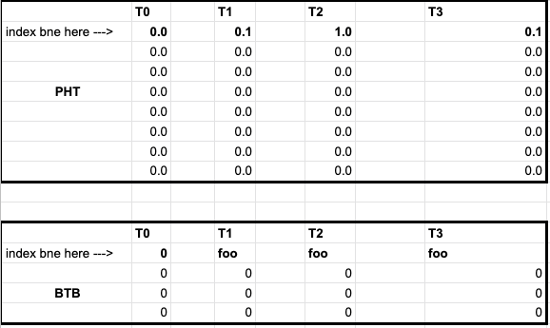

HW3

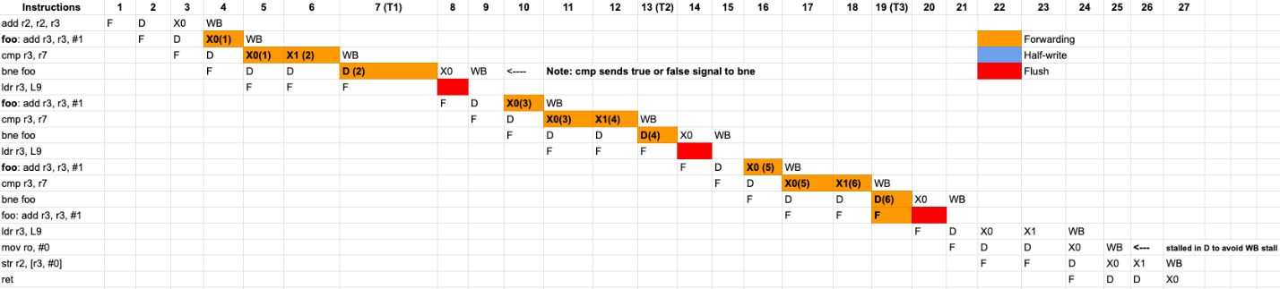

Question 1:

log_2(128) = 7

32 - 7 - 17 = 8

2^8 * 2 = 512

Question 2:

(512 x 1024) B / 16 B = 32768 B

32768 / 2 = 16384 lines

lg(16384) = 14 bits

lg(16) = 4 bits

图形用户界面

Question 3:

(512 x 1024) B / 16 B = 32768 B

32768 / 2 = 16384 lines

lg(16384) = 14 bits

lg(16) = 4 bits

Question 4:

Old = 1.35 + (0.5 x 0.035 x 25) = 1.7875

New = 1.35

Speedup = Old / New

Question 5:

AMAT_L1 = 0.6 + (1 - 0.6(AMAT_L2))

AMAT_L2 = 18 + (1 - 0.2)(30)

AMAT = 0.6 + (0.4)(18 + (0.8)(30))

